**Community Pasta R Us Inc. Analysis Report**

Student’s Name

Institution Name

Assignment Due Date

**Community Pasta R Us Inc. Analysis Report**

**Section 1**

**Objectives of the Report**

The objective of this report is to analyze the financial and operational performance of Pastas R Us, Inc., a fast-casual restaurant chain specializing in noodle-based dishes, soups, and salads. Insights from the performance of the company will reveal whether the current expansion criteria can be improved or not. The report further analyzes the effectiveness of the loyalty card marketing strategy and identifies feasible, actionable opportunities for improvement.

**Variables of Interest**

The variables of interest in this analysis are square feet, annual sales, sales per square feet, per person's average spending, loyalty card sales, sales growth over the previous year, median income, median age, and percentage of adults with bachelor's degrees.

**Summary of the Descriptive Findings**

The table below shows a summary of descriptive findings of the variables in the dataset.

|  |  |  |  |  |  |  |  |  |  |
| --- | --- | --- | --- | --- | --- | --- | --- | --- | --- |
|  | SqFt | Sales/ Person | SalesGrowth % | LoyaltyCard% | Sales/Sqft | MedIncome | MedAge | BachDeg% | Annual Sales |
| Mean | 2580.47 | 7.04 | 7.41 | 2.03 | 420.31 | 62807.70 | 35.20 | 26.31 | 1059381.31 |
| Std. V | 372.38 | 0.30 | 6.58 | 0.55 | 136.31 | 17782.89 | 3.63 | 6.96 | 278522.25 |
| Skew | 0.52 | 0.89 | 0.48 | -0.74 | 1.21 | 0.29 | -0.16 | 0.14 | 0.35 |
| Q1 | 2400.00 | 6.83 | 3.98 | 1.86 | 332.85 | 46953.00 | 32.53 | 20.25 | 877477.58 |
| Q | 2500.00 | 7.00 | 7.03 | 2.08 | 396.01 | 62757.00 | 35.00 | 26.50 | 1035749.21 |
| Q3 | 2735.25 | 7.18 | 11.42 | 2.33 | 483.56 | 76194.25 | 37.53 | 30.75 | 1228866.96 |
| Q4 | 3799.00 | 7.97 | 28.81 | 3.38 | 987.12 | 114353.00 | 43.50 | 40.00 | 1746600.00 |
| IQR | 335.25 | 0.35 | 7.44 | 0.47 | 150.72 | 29241.25 | 5.00 | 10.50 | 351389.39 |

The figure below shows a box plot for annual sales. From the boxplot, it can be concluded that the annual sales are not symmetric. The boxplot shows that the data is right-skewed. This can be further confirmed by the skew value for annual sales in the above table, which is 0.35. Since the data contains outliers, the IQR is better than the standard deviation for describing the dispersion of the data. This is because IQR is not affected by extreme outliers, and reliable findings are likely to be obtained (Bobbitt, 2021).

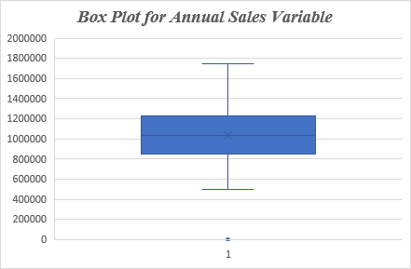

The figure below shows a histogram. The histogram for sales/SqFt is not symmetric; most restaurants range between 260- 520 sales/SqFt. The data in this histogram is right-skewed; there is a longer tail on the right. The variable annual sales has outliers ranging between 910- 1040, and this is higher than other restaurants. The reason behind this could be either that the restaurant is smaller but making higher sales, or the restaurant runs efficiently, making more sales for its size than average. Since the data is right-skewed, the median is the best measure of the central tendency. For a distribution with outliers, the median is the best measure of the central tendency because it is not affected by extreme values as the mean (The Pennsylvania State University, 2025).

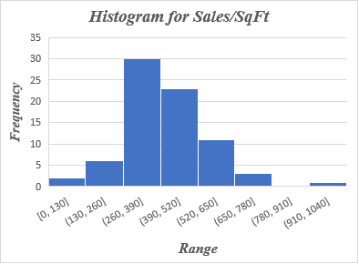

**Section 2: Analysis**

**Scatter Plots**

The figure below shows a scatter plot for BachDeg% Vs Sales/SqFt. The equation is $y=0.0175x+18.975$. The slope of the equation is 0.0175x, which is positive. Therefore, it can be concluded that there is a positive relationship between the percentage of individuals with bachelor's degrees and sales/Sqft. As one variable increases, the other one tends to increase. Areas with more graduates tend to have more sales.

The scatter plot below shows the relationship between MedIncome and Sales/SqFt. The equation is $y=-2.9277x+64038$. The slope of the equation is negative, and this implies a negative relationship between MedIncome and Sales/SqFt. Restaurants in wealthier neighborhoods perform poorly than those in low-income or middle-income areas.

The scatter plot below displays the relationship between MedAge and Sales/SqFt. The equation is $y=-0.0016x+35.871$. The slope of the equation is -0.0016x, and this confirms there is a negative correlation between the two variables. As the median age increases, the sales tend to decrease. Restaurants in areas with young neighborhoods make more sales/SqFt compared to those in older neighborhoods.

The figure below is a scatter plot displaying the relationship between Sales growth % and Loyalty cards %. The equation is $y=-0.0247x+2.21$. Since the slope of the equation is negative, it can be concluded that there is a negative relationship between loyalty card % and sales growth. Presence of higher loyalty card growth has resulted in to decrease in sales growth.

**Section 3: Recommendations and Implementation**

**Effective Expansion Criteria**

Based on the analysis above, it can be concluded that, percentage of adults with a bachelor's degree is positively correlated with sales/SqFt. Therefore, this is an effective expansion criterion. Median household income and median age are negatively correlated with sales/SqFt. The expansion criteria for median household income and median age should be revised to increase sales. The firm should focus on areas with a younger population and middle- or lower-income individuals, as these neighborhood shows stronger sales performance. There is a negative correlation between sales growth and loyalty cards. Restaurants with higher loyalty card usage have slower sales growth. This marketing strategy should be redesigned or changed to increase sales.

**Recommendations to be Adopted**

Based on the insights of this analysis, Pastas R should focus on marketing on younger, educated adults with middle or lower incomes. This group will generate higher sales for the firm. To measure the success of the recommendation above, the company should collect data on customer demographics and sales. Customer demographics data should focus on age, education, and income levels. The customer demographics data can be analyzed to determine what influence they have on sales.

**References**

Bobbitt, Z. (2021). Interquartile Range vs. Standard Deviation: What’s the Difference?

<https://www.statology.org/interquartile-range-vs-standard-deviation/>

The Pennsylvania State University. (2025). 2.2.4.1 - Skewness & Central Tendency

<https://online.stat.psu.edu/stat200/lesson/2/2.2/2.2.4/2.2.4.1>